INSERT
PICTURE
HERE

presenting author name
font : Arial
sizes : 10, except for title 16
Layout template for ICUC9 proceedings
- hints and examples

Author1, Author2, ..., Authorn
1 Institute name, institute address, country, e-mail address
2 Different institute name, different institute address, country, e-mail address
...
n Different institute name, different institute address, country, e-mail address
dated : 15 May 2015

1. Introduction
This document is a template for extended abstracts in 9th International Conference on Urban Climate jointly with 12th Symposium on the Urban Environment – ICUC9. We hope ICUC9 first authors do understand that, event if it is not mandatory, submitting an extended abstract contributes to the quality of the conference and to the dissemination of ideas / results. The purpose of the template is to help ICUC9 first authors in creating a uniform look of the proceedings.

2. The abstract
You are invited to submit your extended abstract in pdf format. ICUC9 will not edit nor review your extended abstract so please check your manuscript extremely carefully.

The template is made for Microsoft Word 6.0 and later versions, Arial font. Maximum length is 6 pages (everything included).

You are invited to include a photo of the presenter. This is to facilitate interaction and connection.

3. Helpful hints

3.1 Emergencies
If for some reason you are not able to use the word template provided, please contact us at icuc9.secretary@meteo.fr

3.2 Images

Feel free to use colour images. It is advisable not to use very thin lines in graphs, but instead dots, dashes or coloured lines.

4. When your manuscript is ready
- Follow the instructions given at //www.conftool.com/icuc9/ to upload your file.

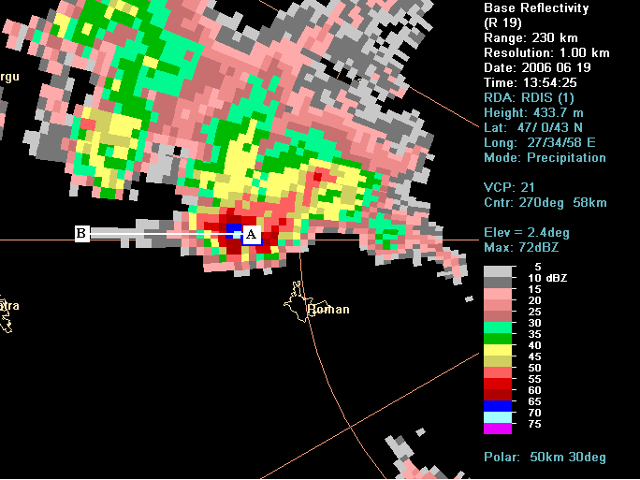
Fig. 1 Arial 10 points Italic is used for captions.

Acknowledgment
ICUC9 PC wants to thank the authors for their effort in preparing the manuscript following these guidelines.

References
FamilyName N., FamilyName M., Year: Title. Journal_name_in_italic, volume, first pagenumber– last pagenumber (Arial 9)

